**SRI LANKA INSTITUTE OF INFORMATION TECHNOLOGY**

Data Warehousing and Business Intelligence

Assignment 2

**ID No: IT20024918**

**Name: Mudunkotuwa N.K**

**Batch: DS weekend**

Step 1: Data source

# Data warehouse designed at the Assignment 1 is used as the data source for this assignment. Data warehouse consists of 7 dimension tables and one fact tables to represent Hotel Booking data altogether.

# 

# 

# I used these data to create OLAP cubes and to generate OLAP operations in Excel and prepare reports in Report Builder.

# 

# ER Diagram

# 

**Data Warehouse Design Diagram**

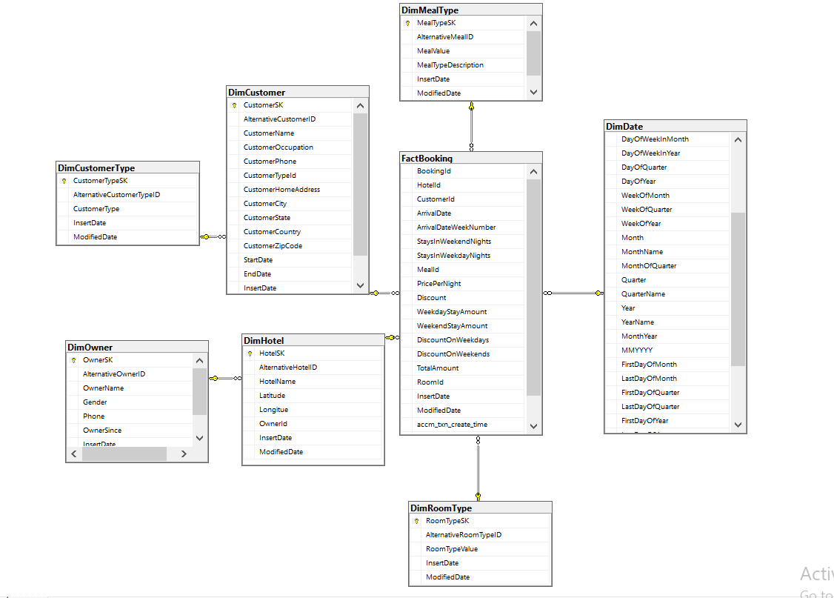

Step 2: SSAS Cube implementation

* Used Tools :- SSAS

SQL Server Management Studio SSDT

When creating the OLAP cubes first I created Analysis Services Multidimensional and Data Mining Project on SSDT. Then I renamed it as “Hotel_Booking_2nd”.Then we can see folder structure as below.

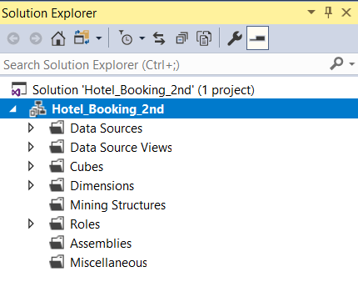

SSAS cube implementation is consist with the following steps.

1. Project Creation

Project creation SSAS project is created in Visual studio for the hotel Booking data in data warehouse. The project is renamed to SSAS_ Hotel_Booking_Assignment2.

1. Data Sources Configuration

Data Sources Configuration In the created project, data source folder is selected under the DS_Hotel Booking Data Warehouse package. After creating a connection to the MS SQL server, ‘Hotel_Booking_Data_Warehouse’ database in sql server has been selected as the data source.

1. Data Source View Configuration

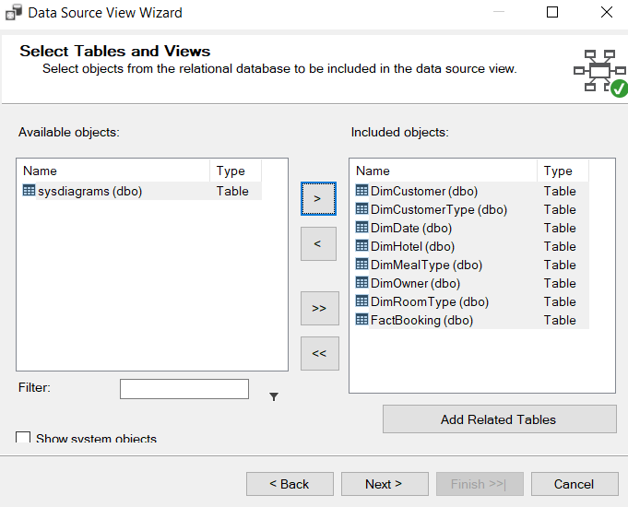

**Data Source View**

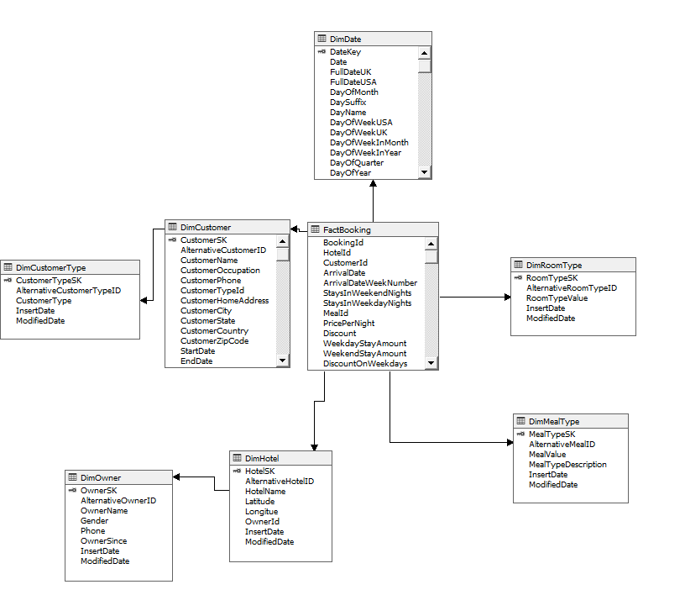

1. Cube Design

In the Cube wizard FactBooking has been selected as the Measure table and DimHotel, DimDate, DimCustomer,DimRoomType and DimealType as dimension tables for the cube.

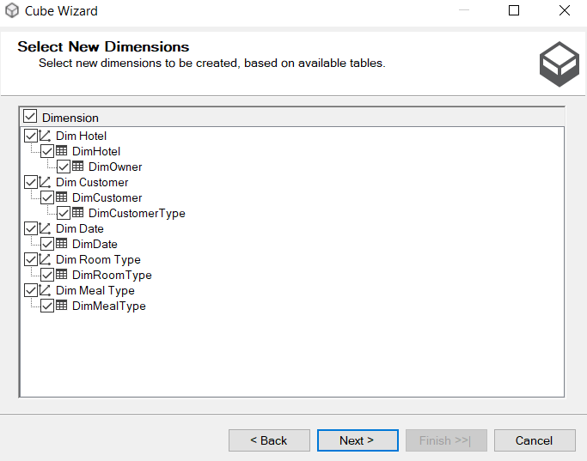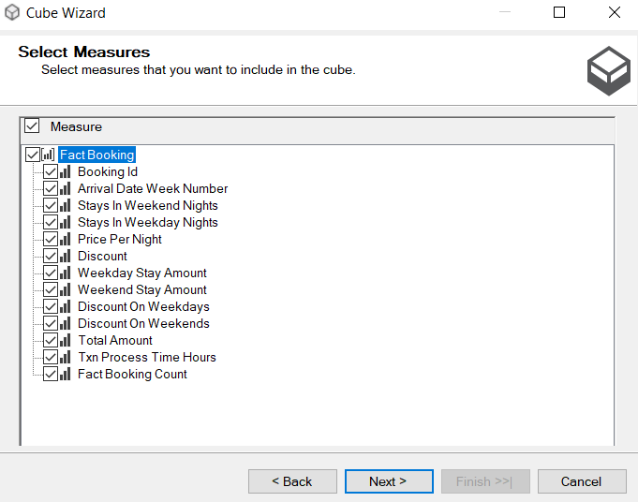

Using measure and dimension cube is designed as below.

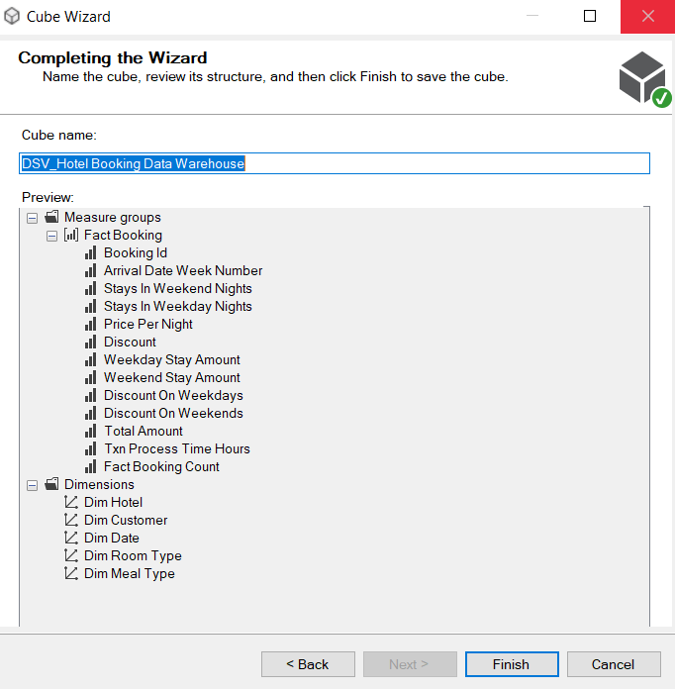

**Cube Design**

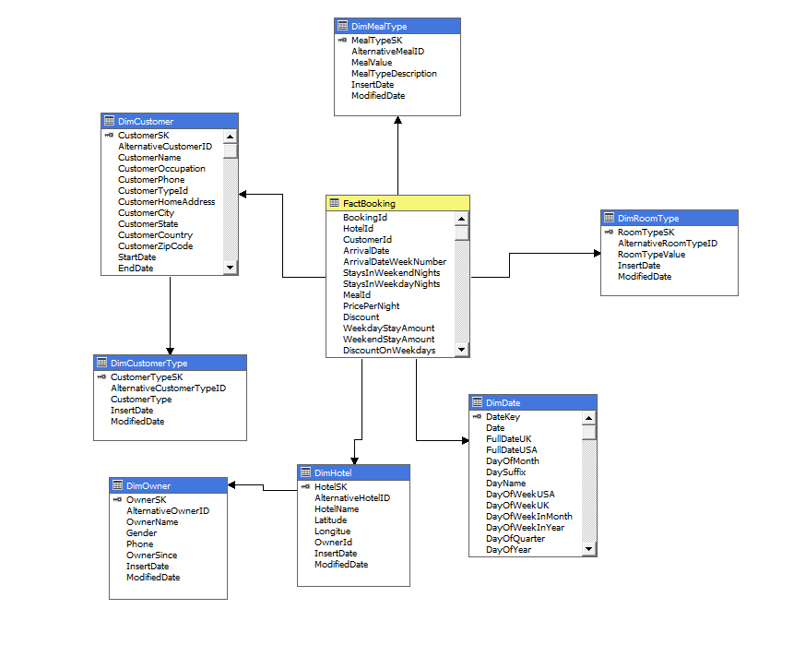

Then I added attributes to all dimensions and created hierarchy to relevant dimensions.

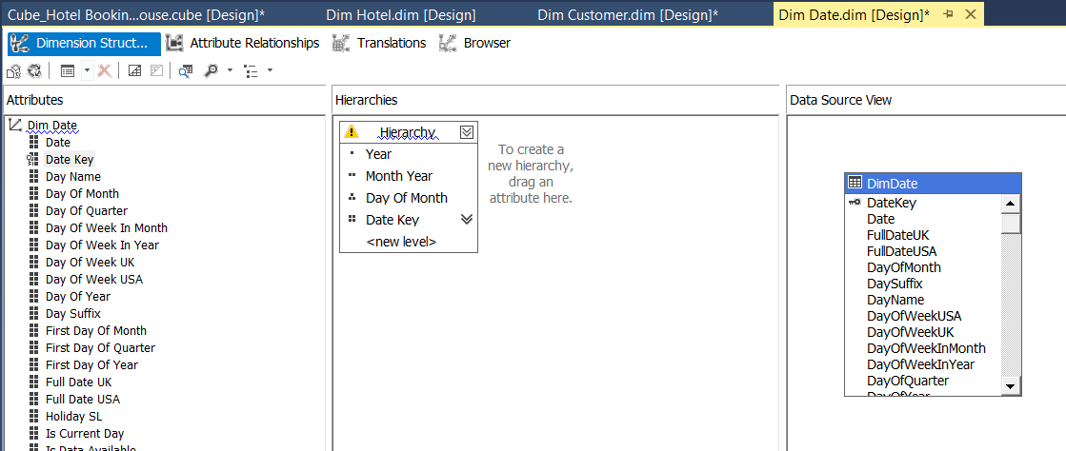

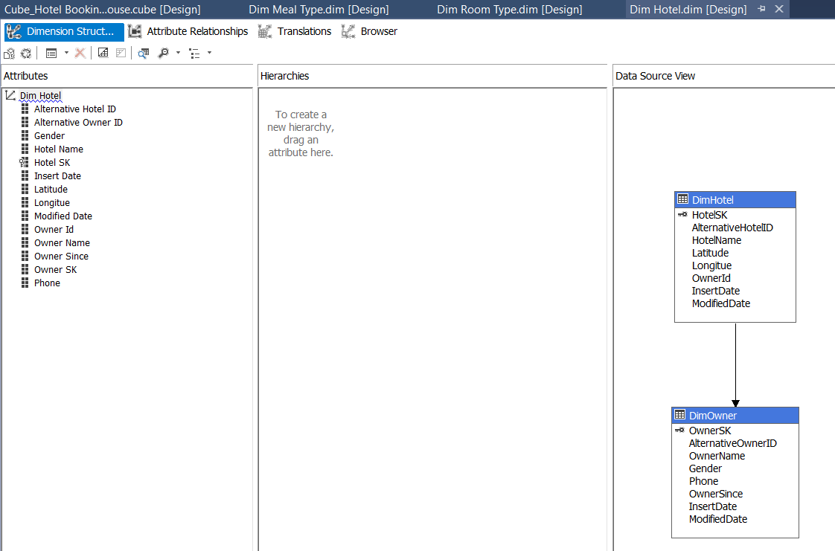

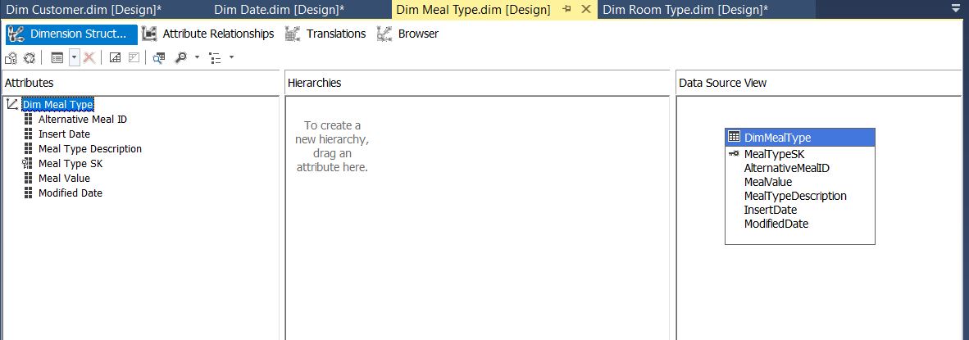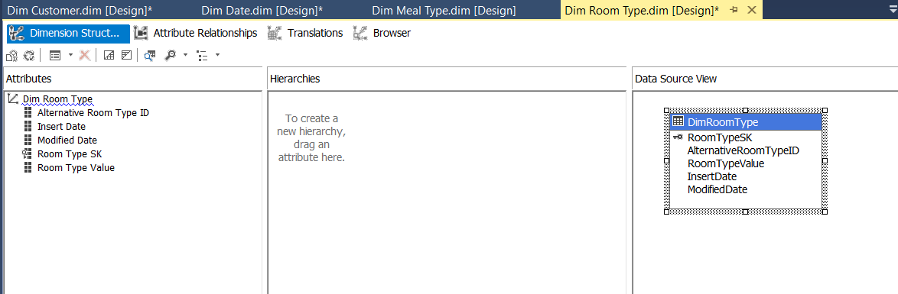

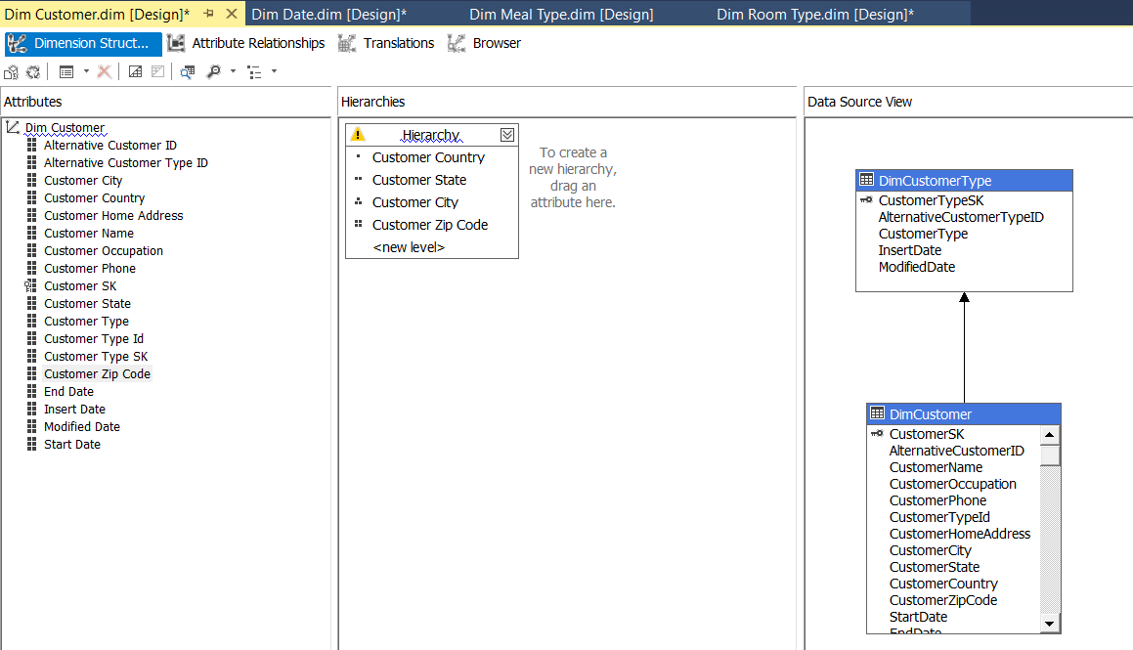

Then the SSAS was deployed in sql server management studio. The deployed data cube contains the fact booking measure table with DimRoomType, Dim Customer,DimDate,Dim MenuType,DimHotel tables dimension tables.

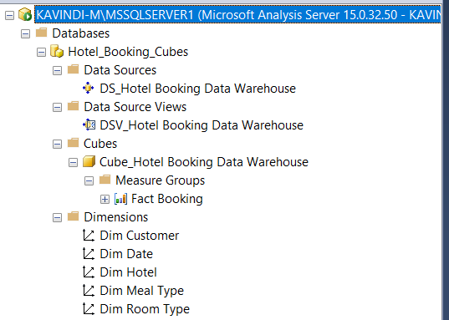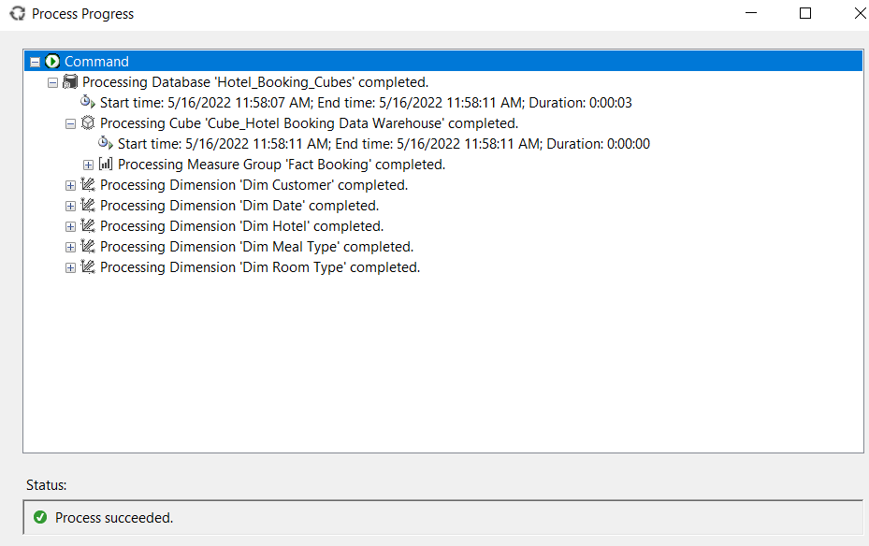

KPI Creation

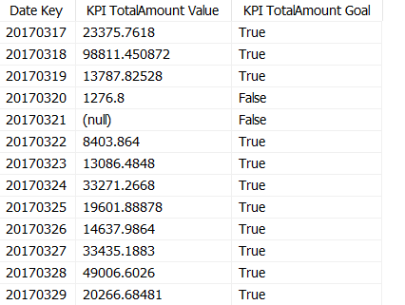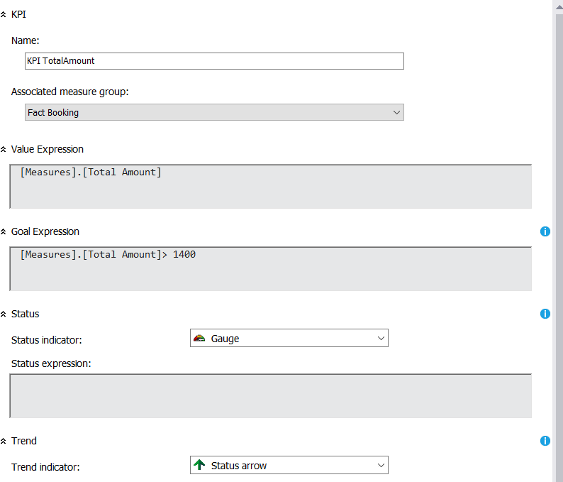KPI is designed on TotalAmount attribute of Measures. It checks if the TotalAmount more than $1400.If so value is set to success(True) else set to fail(False).

Browse Cube Data

Browsing data is done via using SSMS. By connecting SSAS to SSMS using instance and MDX queries can generated by selecting the relevant fields from the dimensions. When browsing cube data, a KPI value or measurement value is compulsory .Otherwise it will not be executed. Below figure shows how to browse data in SSMS.

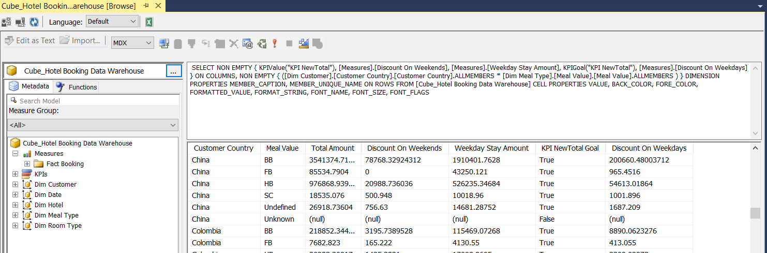

Step 3: Demonstration of OLAP Operations

In the data tab of excel Microsoft analysis services are selected from other sources.There the relevant database to create the pivot table “Hotel_Booking_Cubess” database is selected.Then the data there gets imported as a pivot table report.

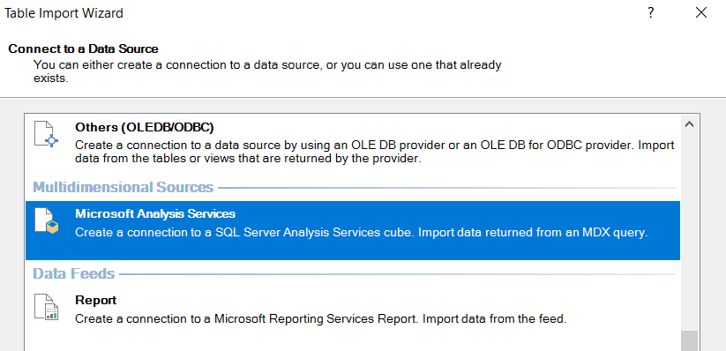

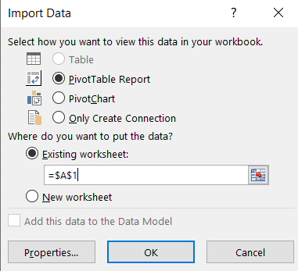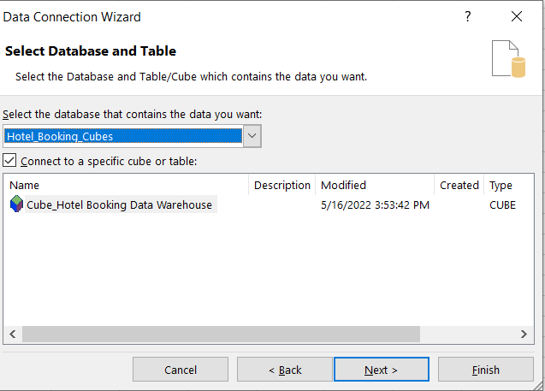

To display the OLAP operation first , the Excel is connected to SSAS cube using MDX query. MDX query is created using above process . And below picture show how to connect the Excel to SSAS Cube successfully.

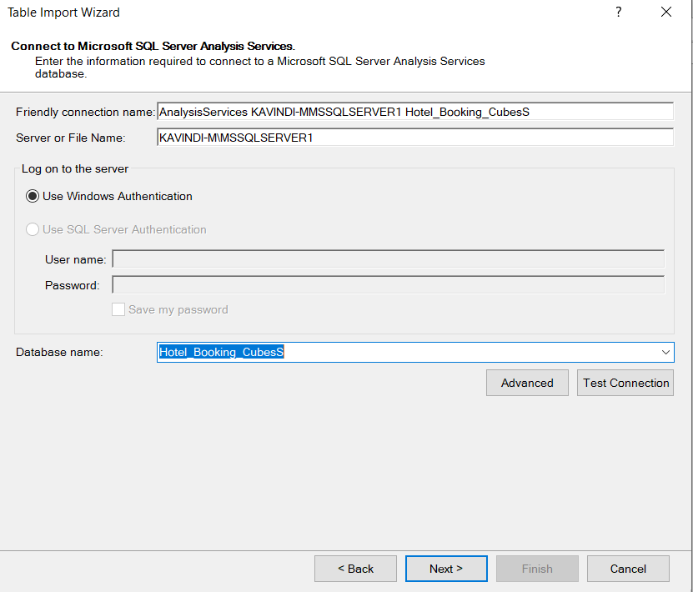

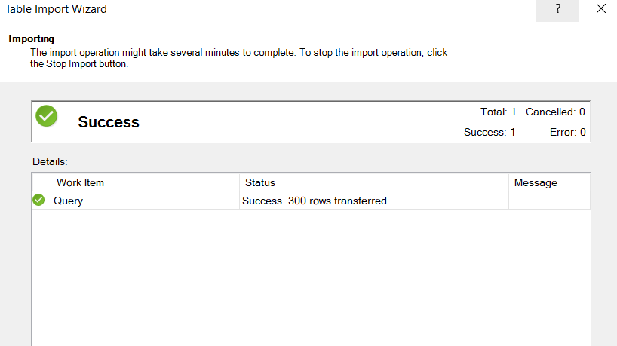Then, this shows how to successfully insert MDX query for generating data to create OLAP operations.

(1)Roll up

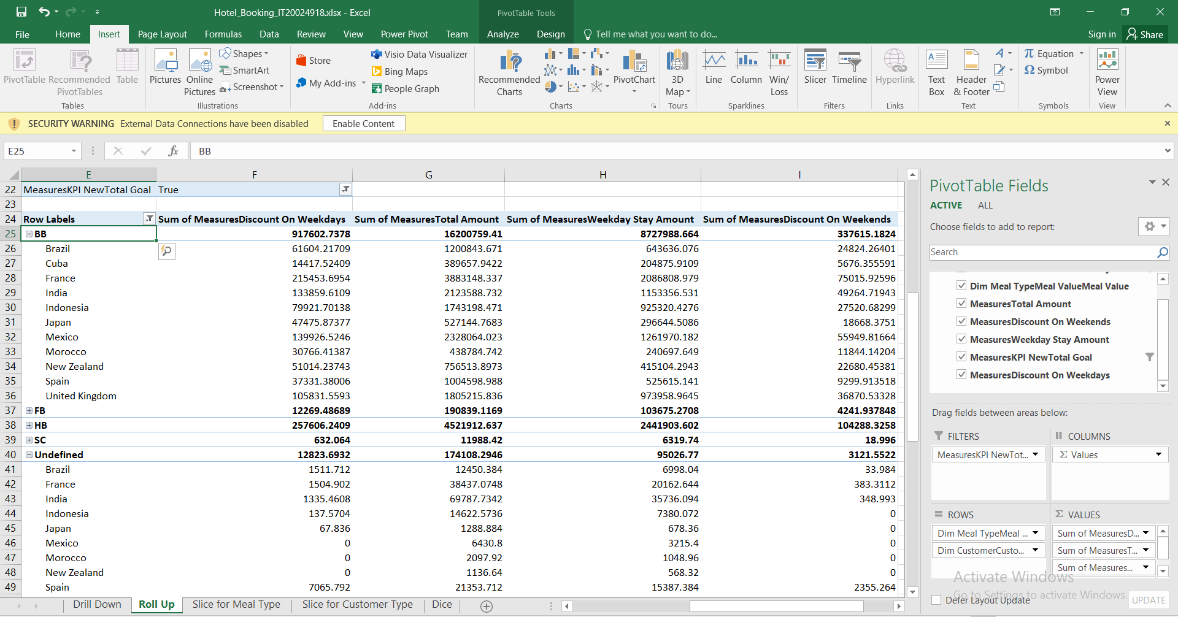It can be seen weekday stay amount, discount amount on weekends and the total amount,discount on weekdays is displayed countries for each meal type. High level understanding can be obtained.

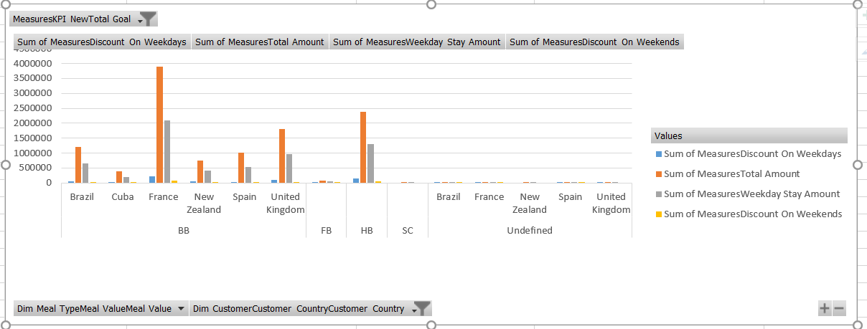

(2)Drill Down

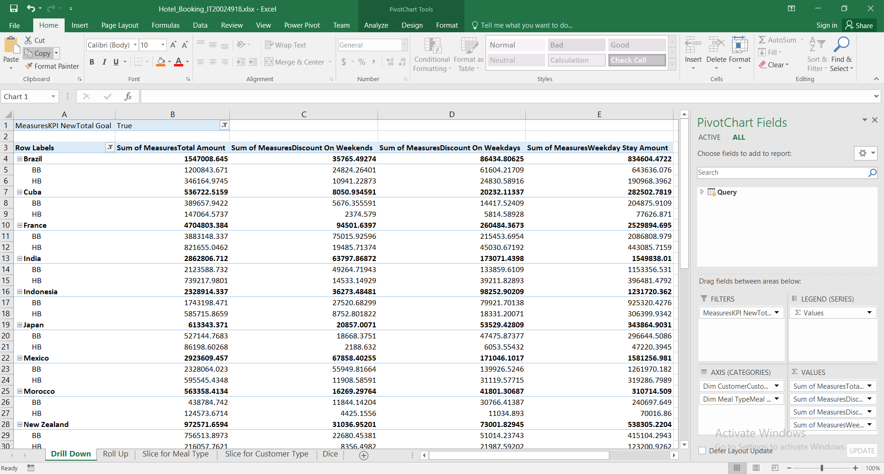By using the countries and meals here I have done the drill down.

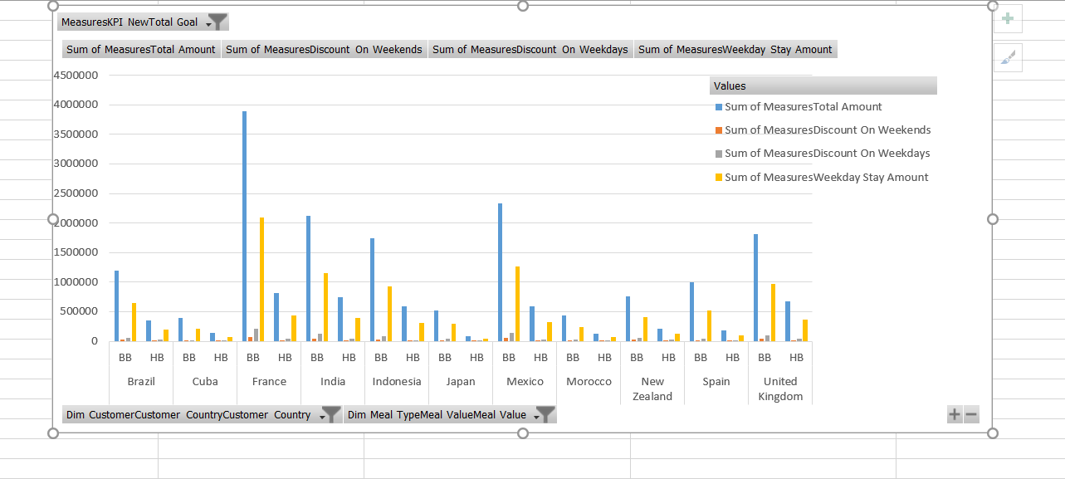

(3)Slice

Slice for Customer

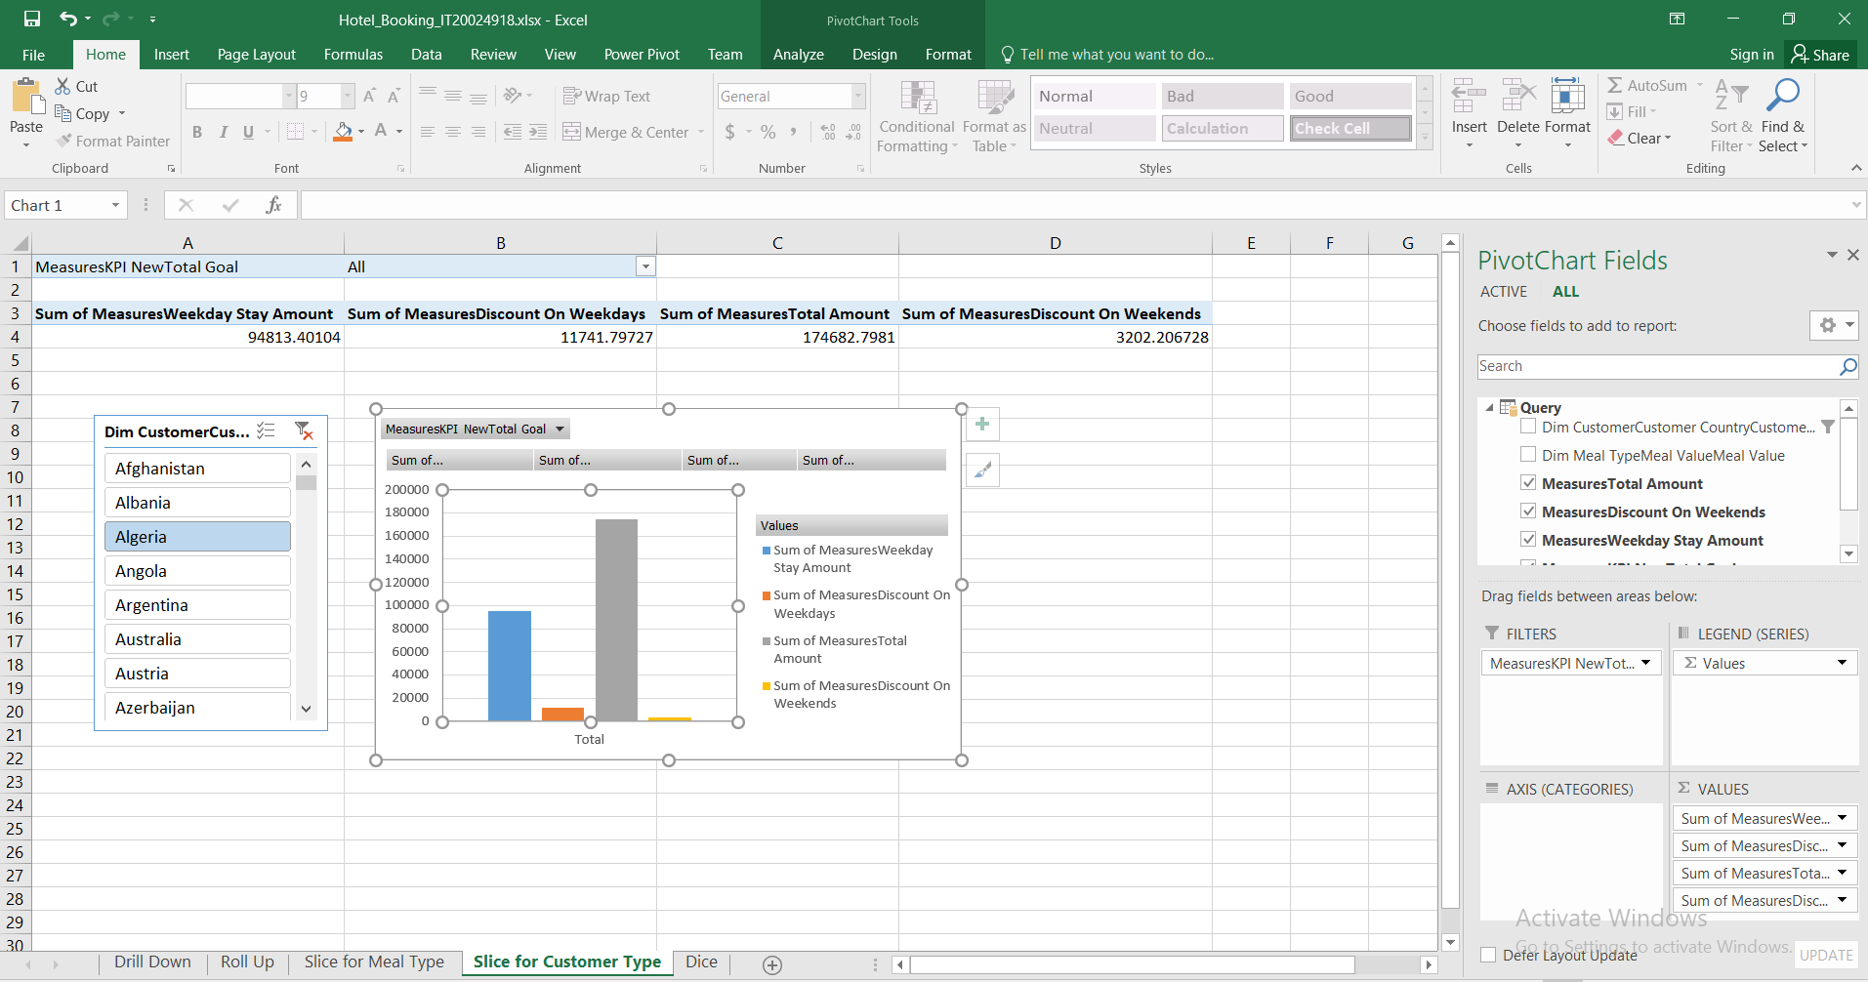

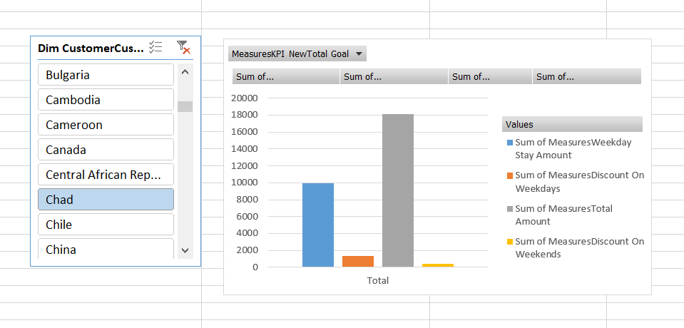

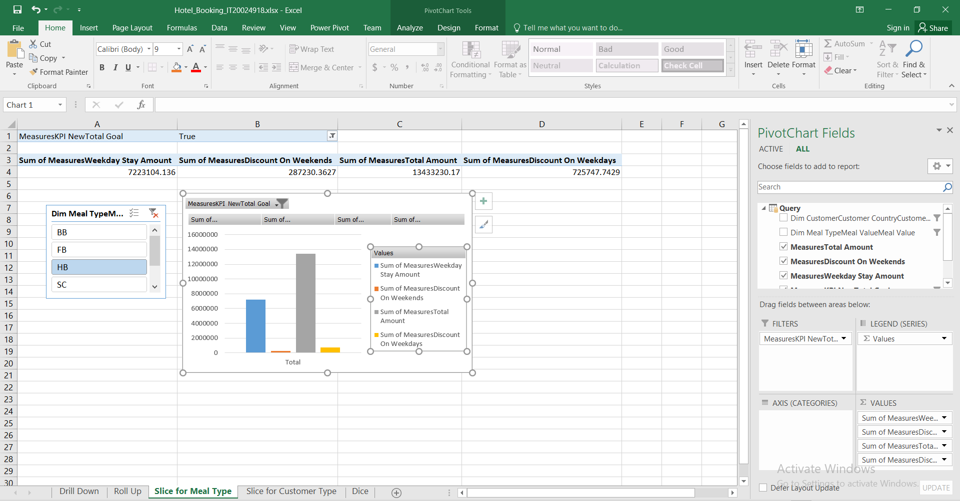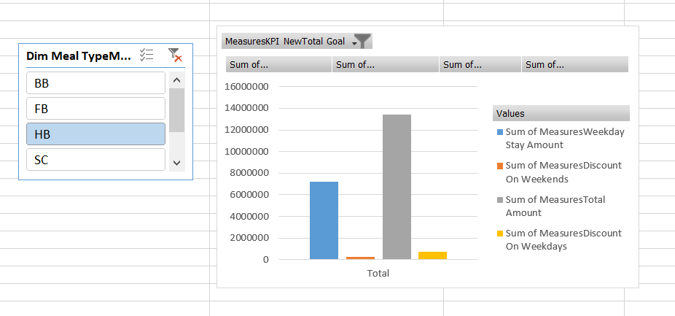Slice for MealType

(4)Dice

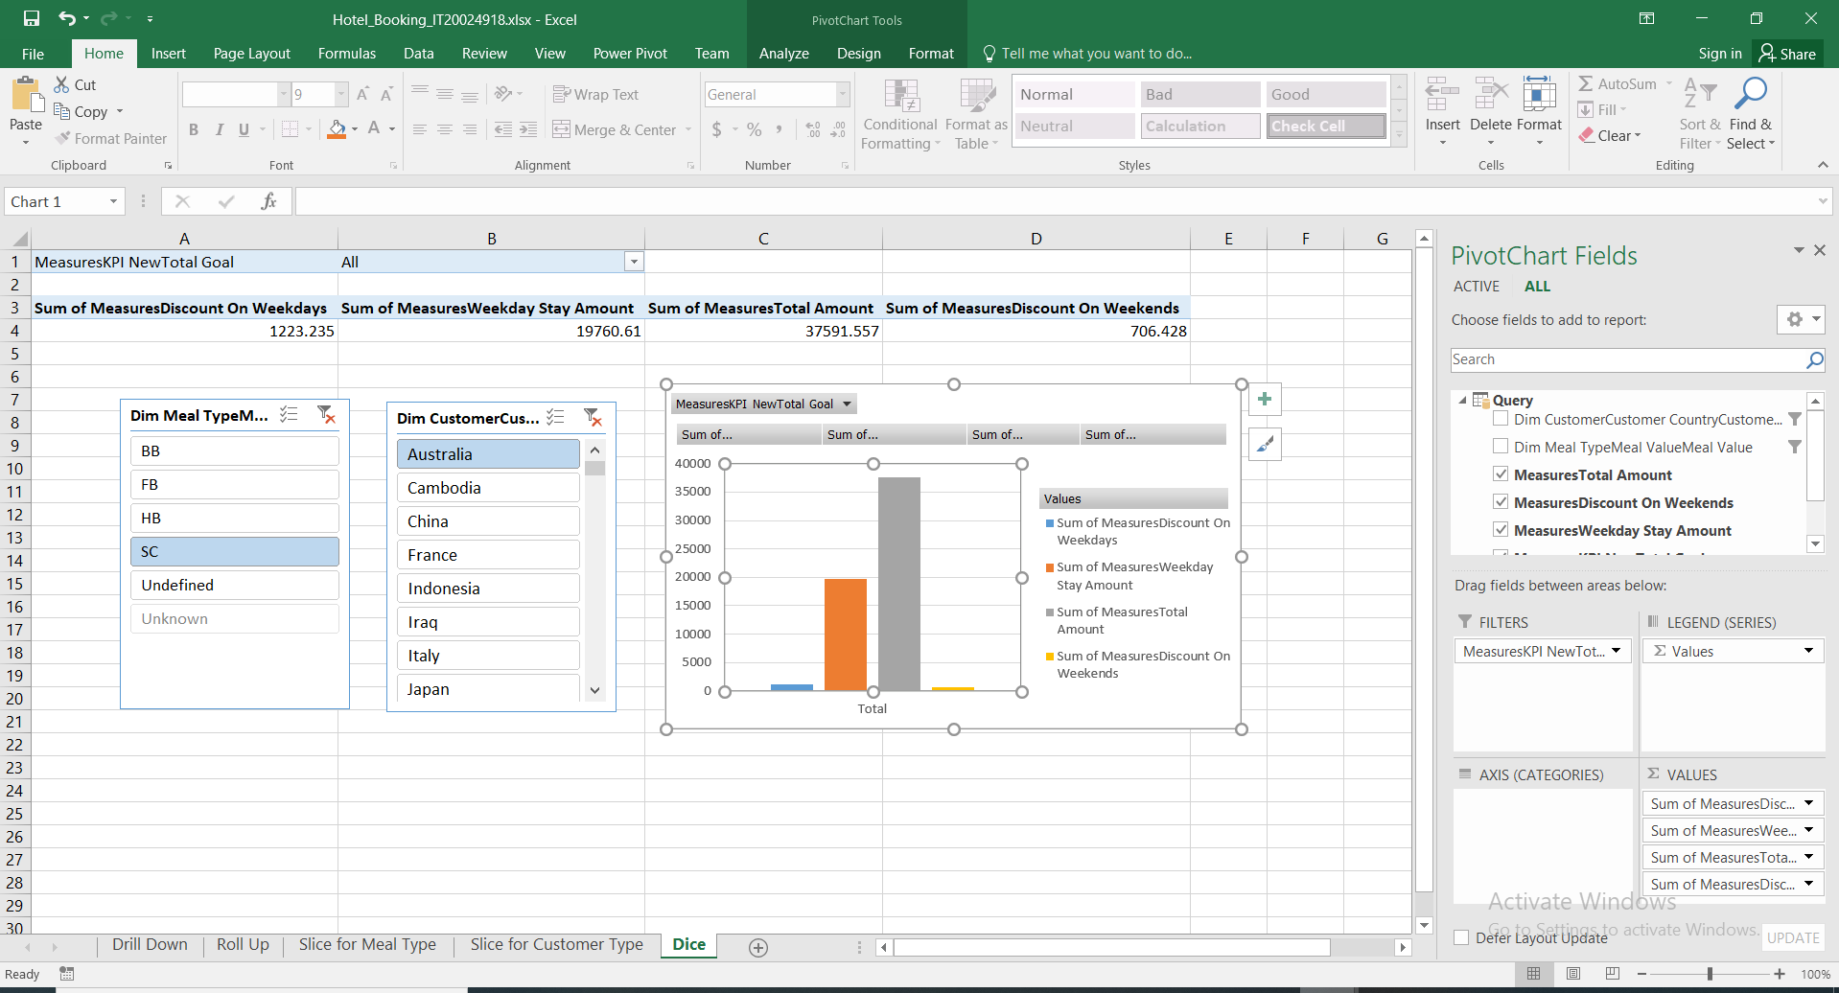

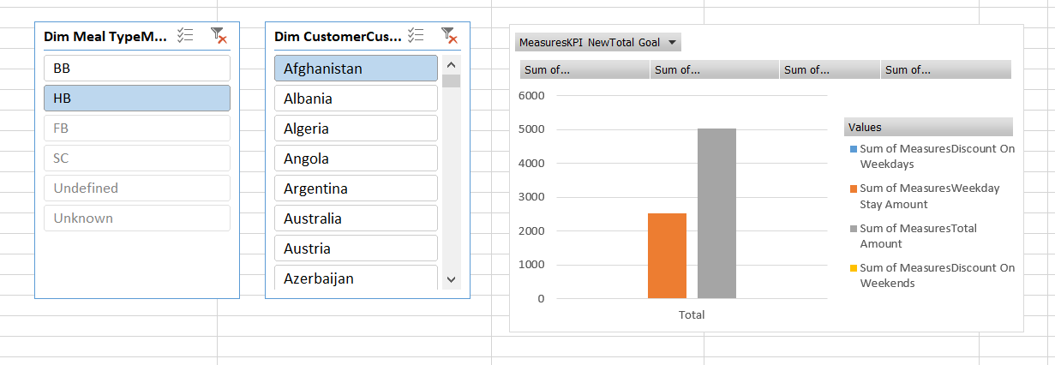

Step 4 – SSRS Reports

Report 1 : Report with a matrix

Below figure shows how to add columns according to the report ,

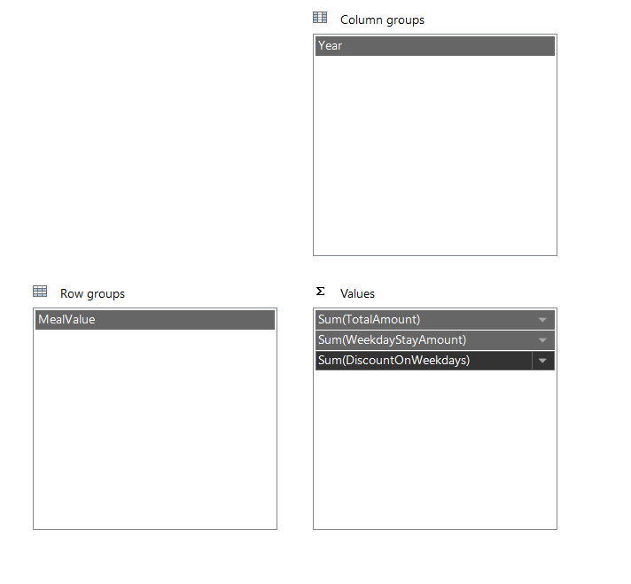

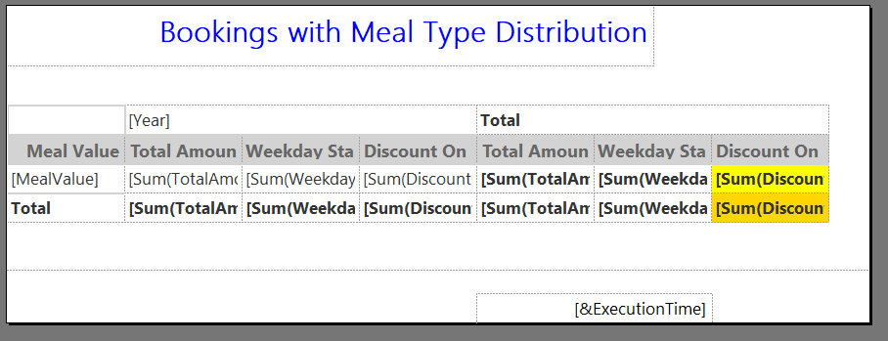I have used meal types to get this report.

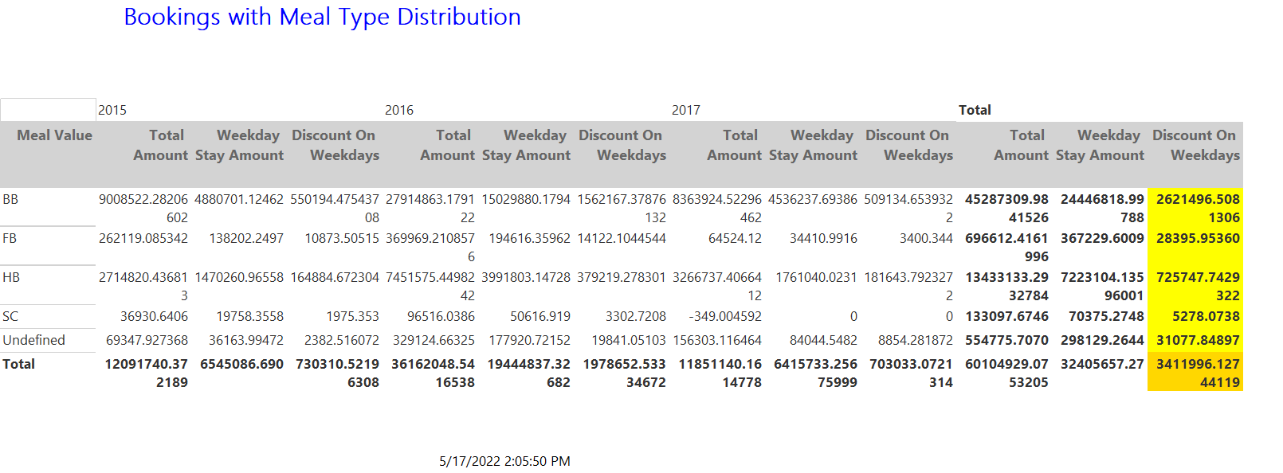

Report 2 : Report with more than one parameter

Below figure shows how to add columns according to the report ,

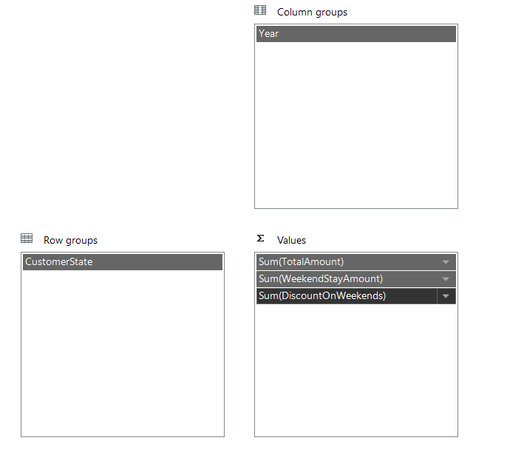

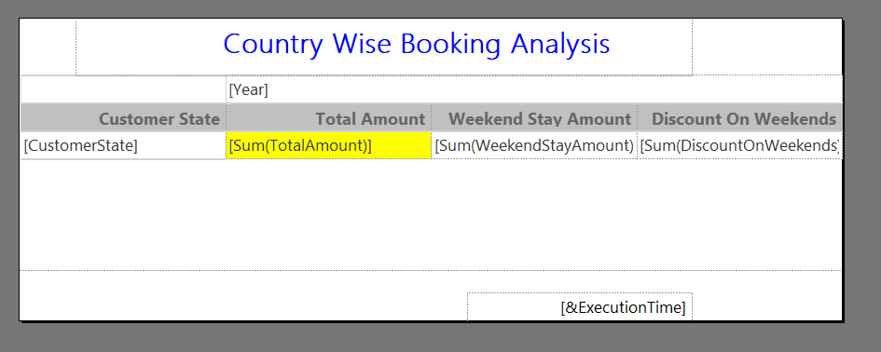Customer state and country has used to do this report.

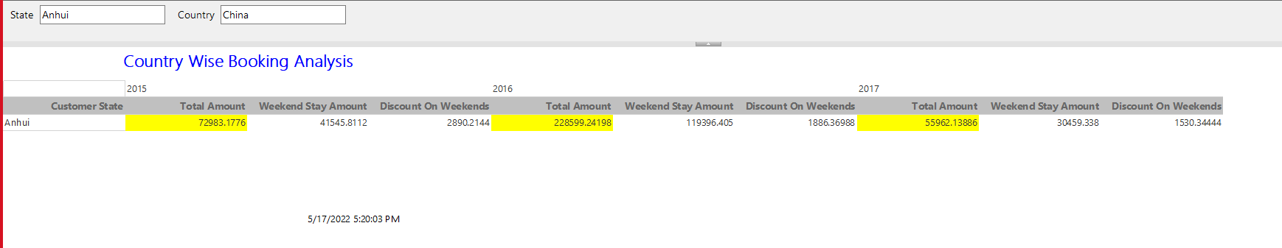

Report 3 : Drill Down

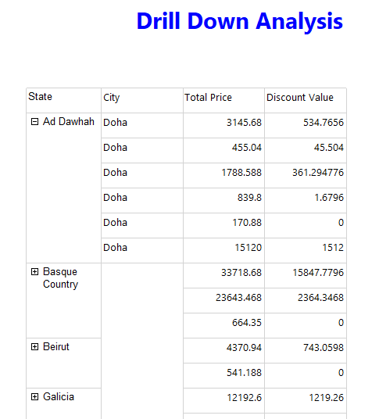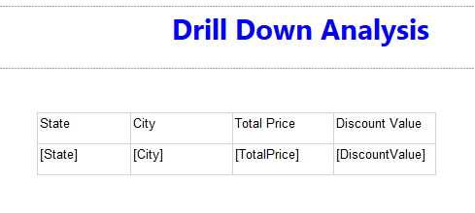We have used state and city to do the drill down.

**Report 4: SSRS drill-through report**

Used CustomerCountry and CustomerState to do the drill through.When you click on the country you will be able to display the relavant state.

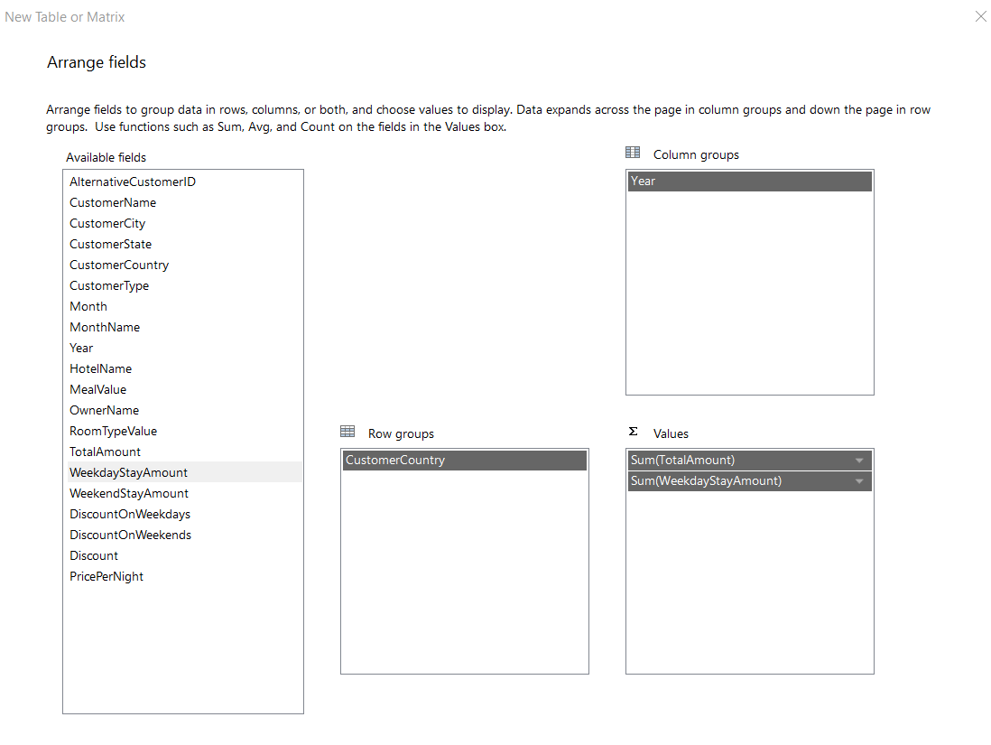Drill through level 1 :

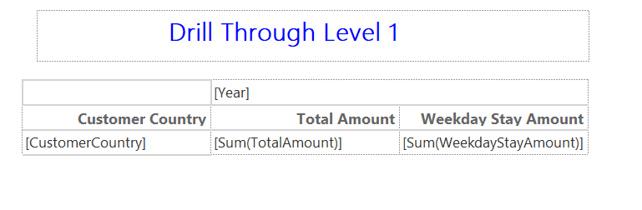Following data are used to get the graph.

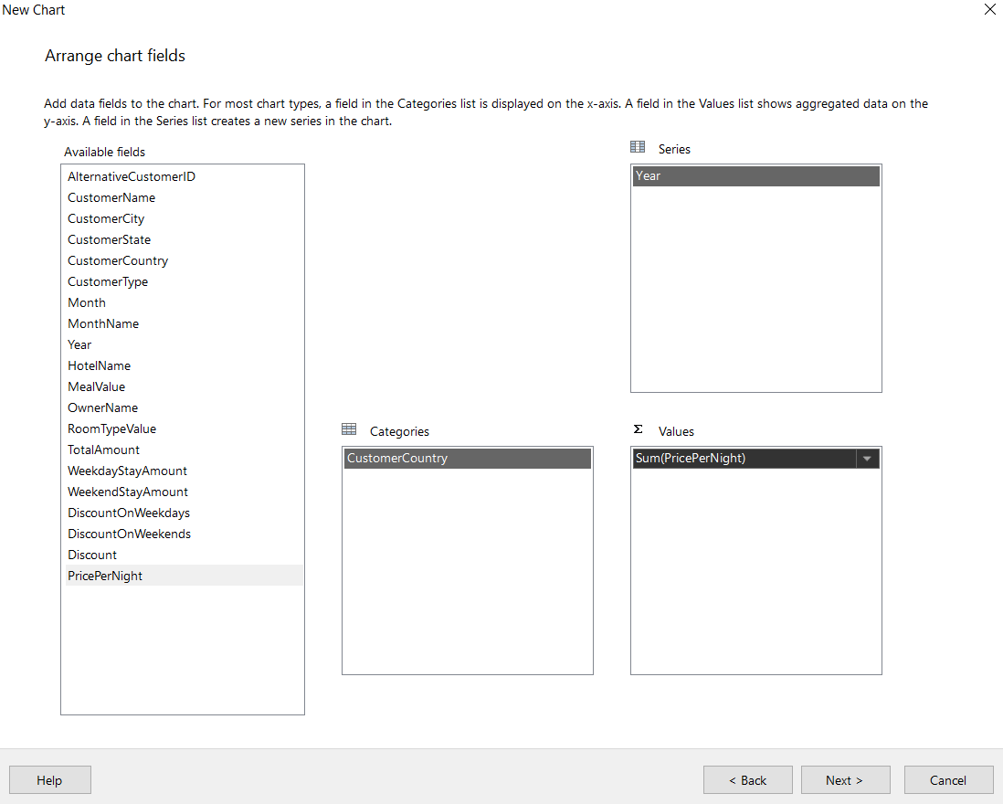

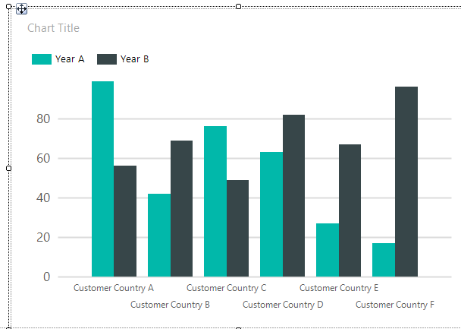

Drill through Level 2 : Used state



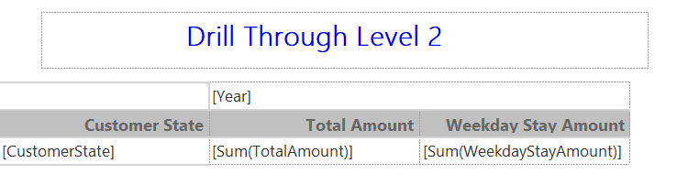

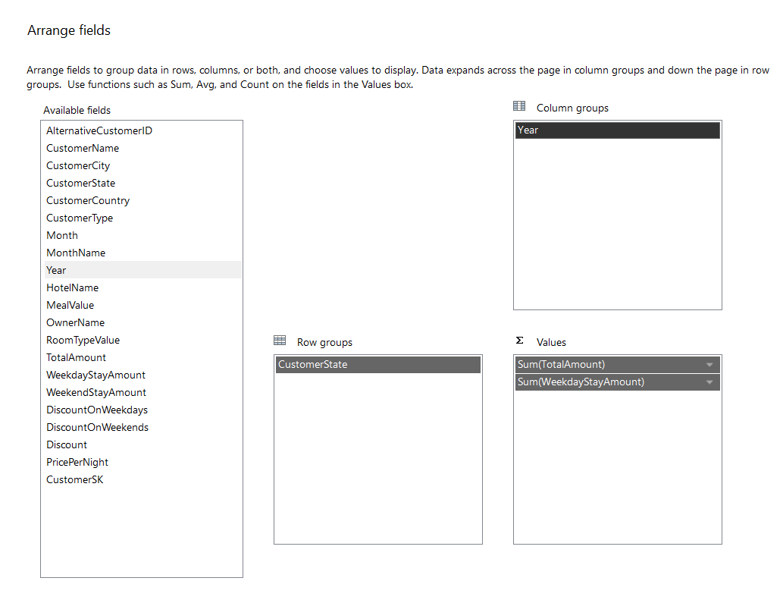

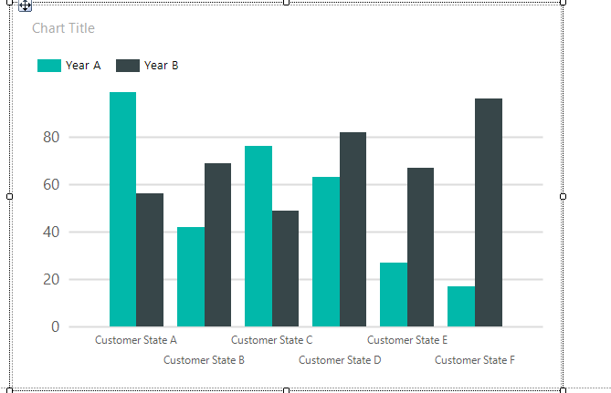

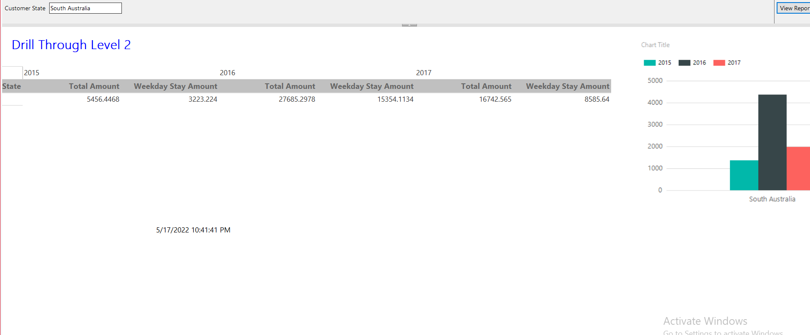

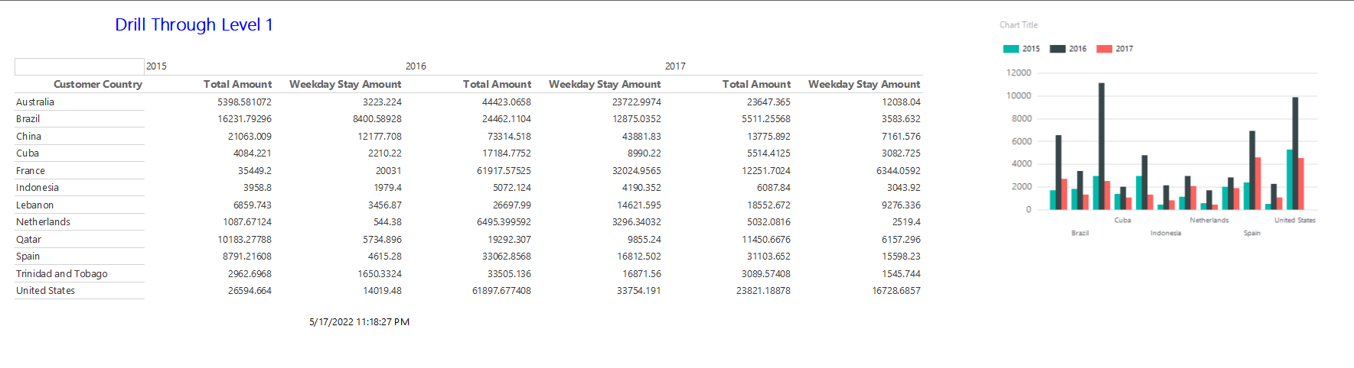

**Final reports**

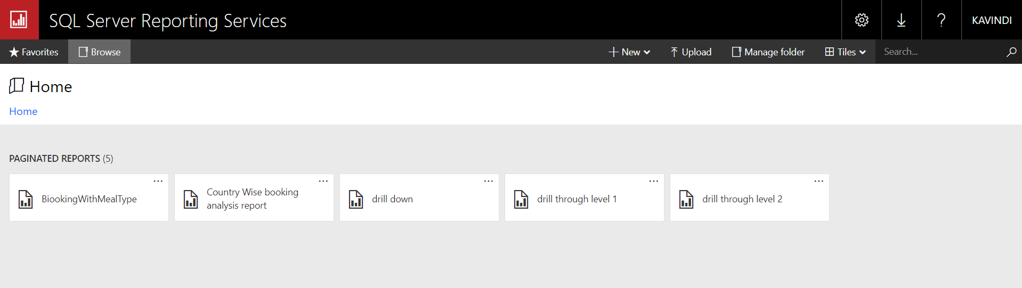

*Thank you!*